Project Design Phase
Problem – Solution Fit

Date | 26 February 2026
Team ID | LTVIP2026TMIDS40509
Project Name | Exploratory-Analysis-Of-RainFall-Data-In-India-For-Agriculture
Maximum Marks | 2 Marks

Problem – Solution Fit Template
Problem Statement:
Indian farmers heavily depend on rainfall for agriculture, but due to climate change and unpredictable weather patterns, rainfall has become irregular and unreliable. Inaccurate weather reports and sudden changes in temperature often lead to poor crop growth, overwatering or drought conditions, and financial losses for farmers. To address this issue, a reliable rainfall prediction and climate monitoring system can be developed using historical weather data and advanced analysis techniques.
Our Solution:
This solution helps farmers plan irrigation schedules, manage water resources effectively, make informed farming decisions, reduce crop loss, and ultimately improve productivity and income. We achieve this through a Machine Learning web application that processes real-time weather inputs (like Temperature and Humidity) through a trained Random Forest model to provide instant, actionable predictions.

Purpose:

- Target Customers: Small-scale and commercial farmers in India, as well as agricultural district planners.
- Problems/Pains: Financial loss due to unexpected rain or dry spells and the complexity of professional meteorological tools.
- Root Causes: Highly variable climate data and lack of localized, simple prediction tools for the common user.
- Customer Behaviour: Farmers currently rely on traditional knowledge or generic news broadcasts which may not be precise for their specific location.
- Existing Solutions: Government weather stations provide general area forecasts, but they often lack a simple, interactive interface for specific "What if?" scenarios.
- Our Effective Solution: Our Flask-based application provides a "low-friction" entry point where a user enters simple metrics and receives an immediate "Rain" or "No Rain" prediction powered by high-accuracy ML algorithms.

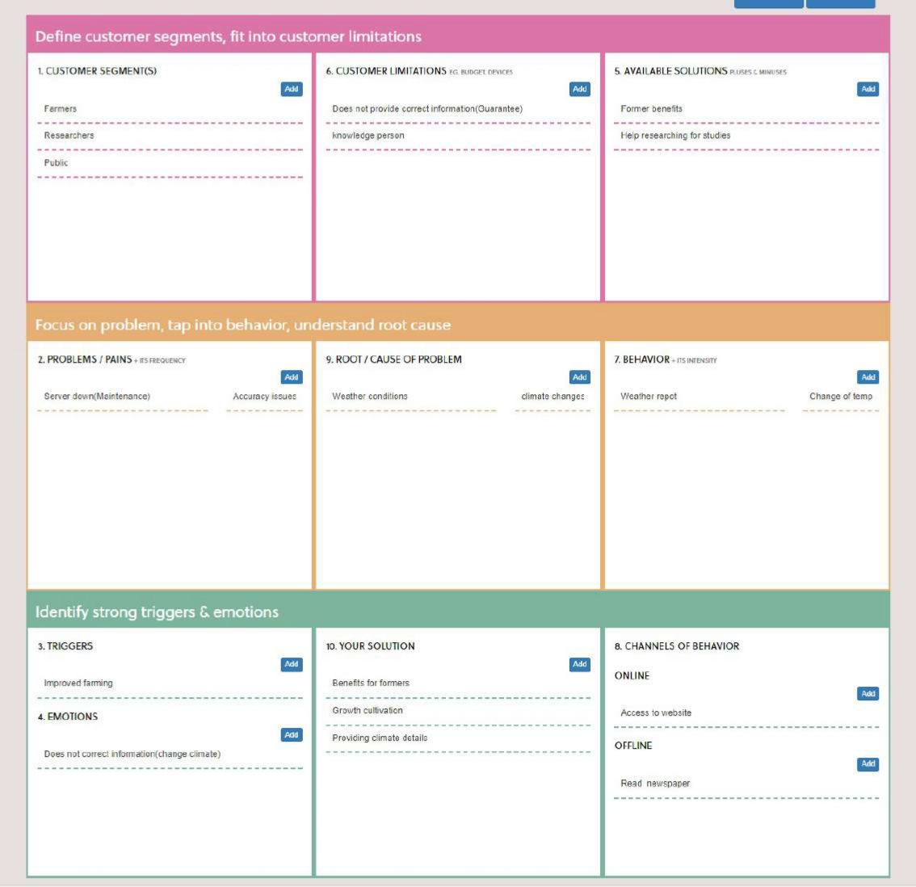
Template:

